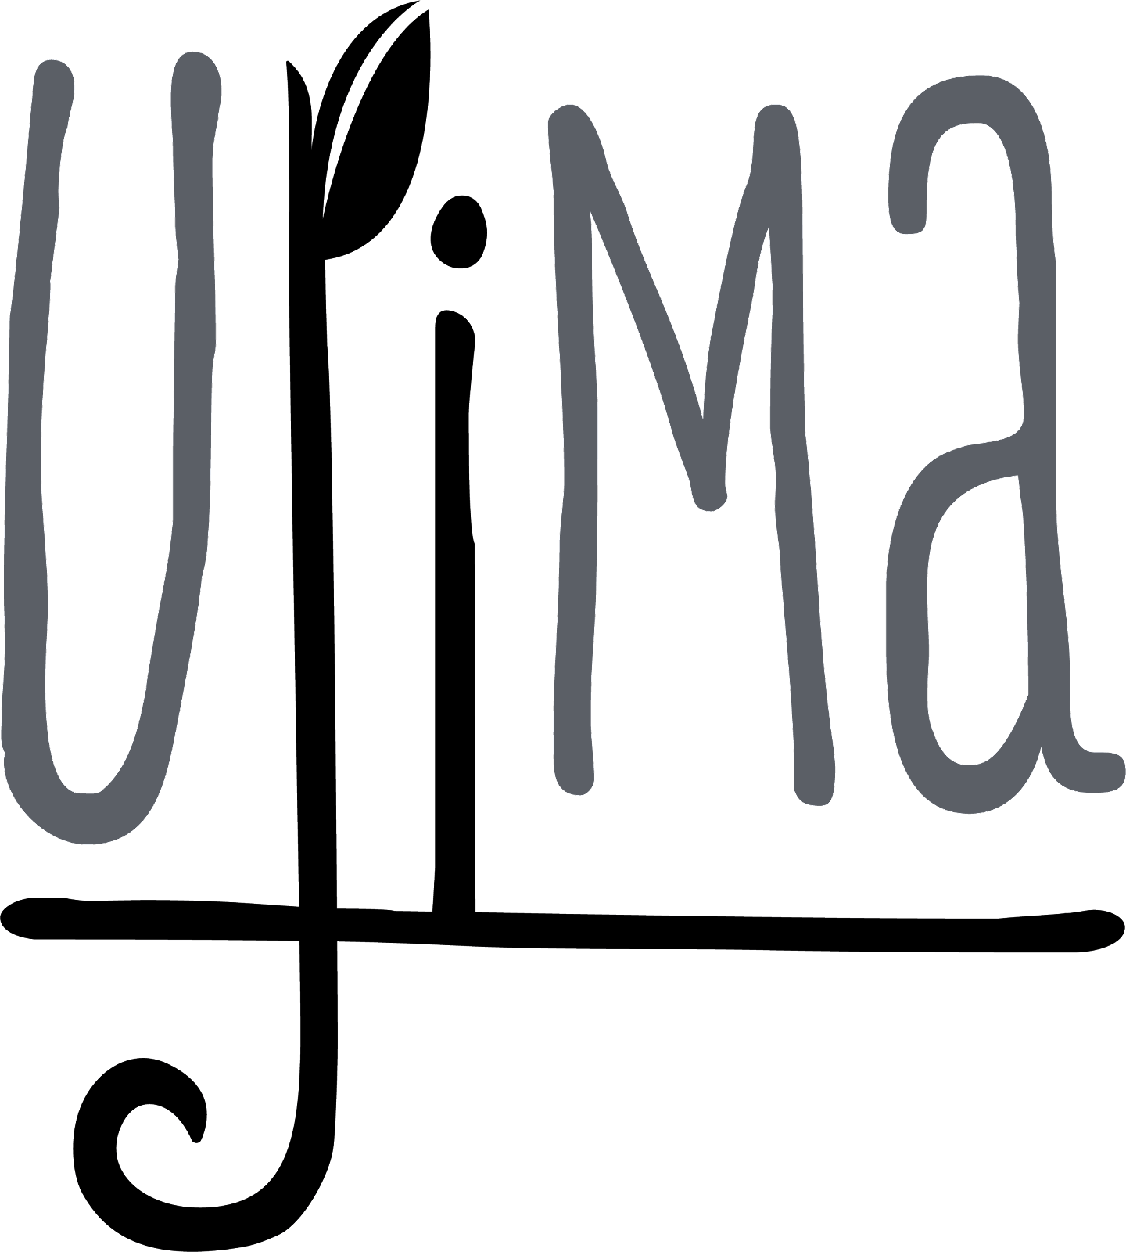

Volunteer Waiver

Dear Volunteer,

**Purpose:** Ujima is requesting volunteers to support our community garden and urban farm. The volunteering will include learning how to grow and maintain fresh foods that can be shared with the communities most in need. Participants will assist with weeding, watering, and other garden tasks. The food will be shared with the community through organizations such as a Red Circle, Solidarity Economy, City Greens Market, and Operation Food Search. This food will go to feeding those most in need of fresh and healthy food during these difficult times. Further, as Ujima hosts events for fundraising, volunteers will be invited to participate and assist if available.

This opportunity will allow volunteers to gain gardening skills, work experience, and support a local nonprofit startup, Ujima. Further, they will be given the opportunity to interact with leaders of a local startup and find out how local startups are created and maintained.

**Volunteering responsibilities include:**

* *Watering the gardens*
* *Weeding raised beds, native garden, or berms in the gardens*
* *Bi-monthly produce and herbs harvest in the gardens*
* *Plant seeds, seedlings, or trees in the gardens*
* *Add compost, mulch, and/or compost tea to beds, native garden, or berms in the gardens*
* *Clean up trash around garden areas*
* *Beautification projects in the garden areas*

**The locations for volunteering are listed below!**

*Clay garden: 3820 North 14th Street*

*Penrose garden: 3714 Penrose Street*

*Solidarity Economy office: 5822 Gravois Ave*

*A Red Circle office: 6439 Plymouth Ave Suite W130*

**Once the form has been completed, Ujima will coordinate with you for which specific days and times you are available for volunteering.**

*Sign this part of the form and return it to Ujima.*

**have permission to attend with *Ujima Volunteering Opportunities*.**

**Printed Name: _____________________**

**Signature: ____________________________________________**

**Date: ______________**

**Phone Number for contact: ________________________________________**

**Email address for volunteer coordination (required) _______________________**

**MEDIA RELEASE FORM**

**(Optional)**

**I hereby grant permission to Ujima to use photographs and/or video of my child taken during volunteering efforts in publications, news releases, online, and in other communications related to the mission of Ujima.**

**​**

**Printed Name: _________________**

**Signature: ___________________________________**

**Date: ________________**

**Liability Form**

On behalf of myself and/or my son, daughter, or person for whom I serve as legal guardian (the “Participant”), I acknowledge with my signature that the Participant wishes to participate in volunteering with Ujima.

I understand that by participating in volunteering activities and programs there is an inherent risk of potential exposure to infectious diseases, including but not limited to COVID-19/Coronavirus. The risk of potential exposure cannot be eliminated, but all available precautions will be taken by Ujima to limit exposure. On behalf of myself, the Participant, my heirs and dependents, personal representatives, assigns and insurers, I now voluntarily and knowingly release and hold harmless Ujima, its officers, employees, volunteers, agents, successors in interest, insurers, contractors, suppliers, vendors, assigns, and any persons or entities with which/whom Ujima is affiliated (hereinafter collectively referred to as “Ujima”), from any and all liability, lawsuits, or claims for injuries, death, or property damage resulting from, arising out of, or in any way connected with Participant's participation in the activities and programs (collectively “Claims”), including but not limited to Claims arising out of or in any way related to any emergency medical care administered, any illness or infection or disease, and COVID-19 or Coronavirus related health issue or exposure. This waiver and release shall apply even in the event that such personal injury, death, or property damage is caused or contributed to in whole or part through the passive or active negligence of Ujima (with the exception of sole, active negligence).

I agree to defend, hold harmless, and indemnify Ujima from and against any and all Claims (including attorney’s fees) arising out of, or in any way related to Participant’s participation in the activities and programs, any actual or alleged negligence of myself or Participant, any emergency medical care administered, any illness or infection or disease, and/or COVID-19 or Coronavirus related health issue or exposure.

I/WE HAVE READ THIS WAIVER AND RELEASE IN ITS ENTIRETY. I/WE FULLY UNDERSTAND IT, AND RECOGNIZE THAT THIS WAIVER AND RELEASE IS A LEGALLY BINDING DOCUMENT. I/WE UNDERSTAND THAT BY EXECUTING THIS WAIVER AND RELEASE, WE ARE VOLUNTARY ASSUMING THE RISKS DESCRIBED HEREIN, AND WAIVING OUR LEGAL RIGHTS ASSOCIATED THEREWITH.

**Printed Name: _____________________________________**

**Signature: ____________________________________________**

**Date: ________________**